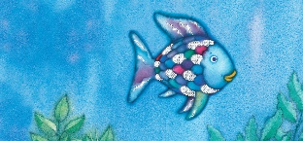
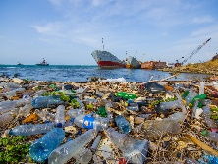

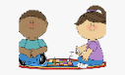
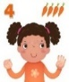
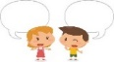
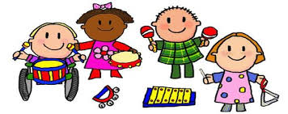
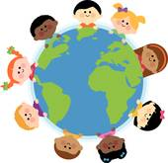

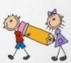
LITERACY
Read about sea creatures using non-fiction texts and PowerPoints.
Draw, label and write captions about our favourite sea creatures.
Read the story ‘Rainbow Fish’. Draw a story frame, depicting characters, setting and write simple sentences about the main events.
Read, learn, and recite some poems as a whole class from ‘Commotion in the Ocean’ poetry book
Take orders, write menus in the Seaside
Café role play
Design a ‘Save our Oceans’ poster

St Paul’s CE Primary School Reception Knowledge Organiser
Topic: Under the Sea
Summer Two
COMMUNICATION AND LANGUAGE
Engage in Non-Fiction Texts about sea creatures, and the season of Summer, developing new vocabulary
Ask how and why questions about sea creatures What do we already know? What do we want to know?
DEFINITIONS
Sea: The wide area of salt water that covers most of the earth's surface and surrounds the land.
Sea Pollution: Pollution is anything present or introduced into an environment which causes harm. In the sea there are many kinds of pollution such as rubbish, oil, chemical and even sewage from toilets!
PSED
Use the story ‘Rainbow Fish’ as a stimulus to discuss sharing and selfishness.
In Circle time, talk about what the children could share with a friend. Have there been times when they have been selfish?
MATHS
Create tally charts and pictogram to show our
favourite sea creatures
Solve addition and subtraction story problems using sea creatures as stimulus
Hide small world fish under a blue sea cloth, “Seven went in sea and 2 swam into the cave. I wonder how many are still in there?”
Use the counting/sorting fish to represent numbers in tens frames to help consolidate number bonds to 10, e.g., there are 7 fish, how many more would I need to make 10? I have 10 fish, take 4 away, how many will be left?
Count pennies correctly to pay for items in the seaside cafe

Key Vocabulary: sea creatures, sun, sea, ocean, sand, seaweed, pollution, plastic, recycle, fish, shark, whale, jelly fish, clown fish, angel fish, seahorse, sea turtle, crab, stingray, sun, heat,
Parents as Partners in Learning
Please read every week with your child and bring the reading book into school everyday
If you have any old shoe boxes, please can you donate for our Under the Sea craft activities
Practise recall of double facts 1 to 5 and bonds to 10. Count to 20 and back

EXPRESSIVE ARTS AND DESIGN
Paint and draw pictures of sea creatures
Paint and collage Rainbow Fish
Paper Plate Jellyfish
Create stories with the small world ocean and pirate ship
Make an Under the Sea small world in a box
Dance to the music ‘Aquarium’ by Saint Saens, using ribbons
and scarves and create the sounds of the sea musical instruments
Learn the song ‘Down there under the Sea’
Role-Play chefs and waiters in the Seaside Cafe
Role-Play Pirates on ‘Pirate Day’ and draw Treasure Maps

PHYSICAL DEVELOPMENT
Use stencils to create sea creature pictures
Use scissors to cut out drawn sea creatures for our Under the Sea boxes
Use our whole bodies, creatin sea dances to music

UNDERSTANDING THE WORLD
Use non-fiction books and the internet to find out about Sea Creatures
Discuss how we can keep our oceans clean and safe. Share the story ‘Billy’s Bottle’ as a stimulus. Discuss what happens to sea creatures when the ocean is polluted by oil and plastics. Set up a small world ocean that is clean and compare with one that is polluted. Which would the children rather have?
Discuss and read about the season of Summer
Discuss how to keep safe in the sun and how to keep safe on the beach.
Create stories based on going on holiday in our role-play seaside café and shop – what happens on a seaside holiday? What clothes do we need?

