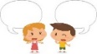
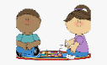
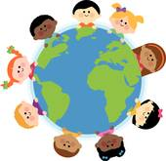
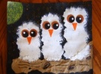
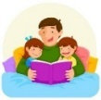
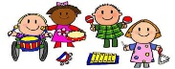
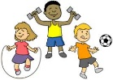
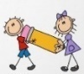
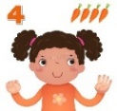
MATHS
One more and one less
Composition of 5 (what numbers added together make 5?)
How many altogether? Combining two groups
Composition of numbers
Matching and making 6,7,8
Making pairs
Adding more
Measuring capacity
Measuring and comparing heights and lengths
Measuring time
Key Vocabulary: owl, squirrel, hedgehog, fox, badger, bat, deer, night, day, dark, light, hibernation, hibernate, nocturnal, prey, predator, sun, moon, sunset, sunrise, honesty, truth, feelings, scared, worried, frightened
UNDERSTANDING THE WORLD
Use non-fiction books and the internet to find out about British Woodland Animals and Winter
Find out which animals are ‘nocturnal’ and which ‘hibernate’ and explore what these terms mean.
Investigate differences between Light and Dark, conduct experiments using torches and reflective strips
Look for signs of winter on a winter welly walk
Conduct ice experiments – how can we free a teddy from the ice? (teddy got lost on a cold night and fell in a puddle!)
Parents as Partners in Learning
Engage in the Learning with Parents Activities sent weekly to your email address
Take your children on a Winter Walk and point out the signs of the season around them.
Listen to your children read every week and sign the reading record book
Help your children to learn to read their ‘tricky words’ by sight
St Paul’s CE Primary School Spring One Reception Knowledge Organiser
Topics: British Woodland Animals and Winter

PSED/RE
Think about the perspective of others whilst discussing the Owl Babies story characters, e.g. Why does Bill ‘want his Mummy’?

Discuss the value of ‘Honesty’ Discuss how being honest makes you and others happy. Link to our rule – don’t cover up the truth. Read the story of Zacchaeus, teach how Jesus taught him to be honest. Make collage trees and Zacchaeus character. Learn the song, ‘’This Little Light of Mine’
PHYSICAL DEVELOPMENT
Dough Disco – work on developing
strength in our fingers for fine motor work
Use scissors to create paper snowflakes
Use our whole bodies with control and coordination to represent movements of bears and squirrels

COMMUNICATION AND LANGUAGE
Retell the story of Owl Babies, once they have developed a deep familiarity with the text; some as exact repetition and some in their own words
Engage in Non-Fiction Texts about British animals and seasons, developing new vocabulary
LITERACY
Write factual sentences and label pictures for a Floor Book about British Woodland Animals
Read stories about Percy the Park Keeper and his animal friends.
Share the story, Owl Babies and learn by rote with Talk for Writing Actions
Innovate the story as a whole class, creating new characters and settings.
Draw Owl Babies Story Maps, write character descriptions and speech bubbles and more able retell story writing simple sentences. ‘Hot Seat’ and ‘Freeze Frame’ activities to explore emotions of the owl babies

EXPRESSIVE ARTS AND DESIGN
Explore ‘hibernation’ through the ‘Bears and Squirrels’ dance
Paint pictures of British animals for the Floor Book
Collage owls
Sponge paint Owl Babies for a display
Role-Play Percy the Park Keeper’s Hut
Create stories with small world woodland animals
Make bats, squirrels and hedgehogs in the workshop using junk materials
Sing songs about British Animals
Starry Night (Van Gough) tin foil paintings
Winter Skies – explore the colours of winter skies, use cold colours to create skyscapes and cut out snowflakes to place on top.

