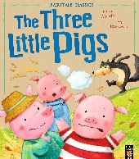

**People Who Help Us** Autumn Two 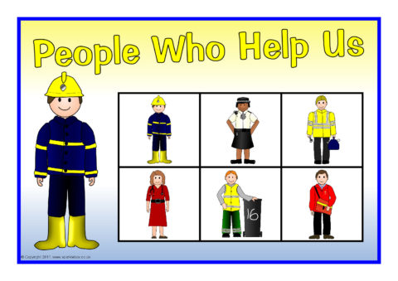Two

Focus Books

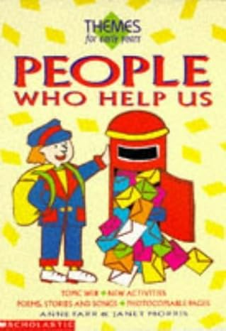

**People Who Help Us**

By William Anthony

**People Who Help Us** By Janet Morris

**The Three Little Pigs** By Mara Alperin

Key Questions

Who are the people who help me in my community?

What job would I like to do when I grow up?

What does a Police Sergeant do?

What equipment is on a Fire Engine?

How often should I clean my teeth?

What can a teacher help me to do?

What materials will build a strong house?

Parents as Partners Sign up at the Library and share story books with your child on a regular basis. Sing Nursery Rhymes with your child, focussing on the ones we will be learning for Nursery Rhyme week, such as Twinkle Twinkle and Incy Wincy Spider.

Activities Visit from a Police Sergeant Build a map of our outdoor area using Duplo and Lego and other construction materials. Learn about Road Safety using resources Discuss people who help us.

Draw and paint people who help us and make a class floor book.

Role-play people who help us.

Discuss what we would like to be when we are older.

Learn the story and actions to ‘The Three Little Pigs’.

Make Story Mountains of ‘The Three Little Pigs’.

. .

Key Vocabulary Police officer, car, van, teacher, builder, firefighter, siren, car, van, stethoscope, mirror, books, bricks, tools, straw, bricks, sticks, big